Title of my CHNT Long Abstract <style CHNT_Title>

Subtitle <style CHNT_Title_Subtitle>
FirstAuthorFirstName LastName, affiliation, country <style CHNT_Name_Affiliation>
SecondAuthorFirstName LastName, affiliation, country <style CHNT_Name_Affiliation>
Keywords: Please add 3 to 5 key words separated by M-Dashes "—". <style CHNT_Keywords>
CHNT Reference: add full reference here: FirstAuthorSurname, G., SecondAuthorSurname, G., and ThirdAuthorSurname, G. (2022). ‘Title of the CHNT Long abstract’, in CHNT Editorial board. Proceedings of the 27th International Conference on Cultural Heritage and New Technologies, November 2022. Heidelberg: Propylaeum.
DOI: xxxxxxx. <style CHNT_Citation_Reference>

Guidelines <style CHNT_Heading 1>
Please follow these guidelines strictly to ensure a smooth and quick review and publication process.

General issues <style CHNT_Heading 2>
These instructions give you guidelines for preparing Long abstracts for the conference “Cultural Heritage and New Technologies” (CHNT). Use this document as a template. Please use Microsoft Word or a compatible free word processor using the styles described in the next section. Long abstracts must be written either in British or American English (the spelling should not be mixed). Please use footnotes instead of endnotes. Use standard abbreviations for metric units (km, kg, m, etc.) without final full stops. Square metres should be expressed as m². Define non-trivial abbreviations and acronyms the first time they are used in the text.
Whenever a number occurs make sure the number is separated with a protected space to prevent a line break between the number and its according information/unit. E.g, 100 km², Fig. 3, Henry VII, Table 1. The protected space is inserted by pressing [Ctrl]+[Shift]+[Space]. Turn on the formatting symbols to check if the protected space is in place.
The length of the long abstract is limited to three to four pages including illustrations, with a minimum of 800 words (not including captions and references); at least one (up to three) illustration(s) are required
Long abstracts must not be written in first person (“the survey project has been planned” instead of “we planned the survey project”) or active voice.
Remember to check spelling. If your native language is not English, please get a native English-speaking colleague to carefully proofread your text.
By submitting the long abstract, you agree that this contribution may be published under the terms of the CC BY-NC-ND 3.0 Licence in the CHNT proceedings. All submissions will be reviewed after submission. It is therefore possible that your submission is rejected, or you will be asked to make some changes before it is published. <style CHNT_Long_Abstract_Text>

Tables and Styles <style CHNT_Heading 2>
Please make strict use of the given styles that have been carefully defined for each part of the Long abstract, listed in Table 1.
When assigning a style to a particular element of the long abstract, first select the section of text that you want to designate with a particular style and then select the appropriate style from the style menu. The style will then adjust your fonts and line spacing. Do not change the font sizes or line spacing to squeeze more text into the maximum number of pages. Please follow this rule carefully: it makes the final shape of your long abstract more uniform and makes production work easier. To highlight words, use italic letters only. Please place the captions of tables in front of the tables.
Table 1. List of the styles used in a CHNT Long abstract. <style CHNT_Table_Captions>
Style | Text involved
CHNT_Title | Title; Arial, 14 pt, bold, space before 24 pt, after 12 pt
CHNT_Title_Subtitle | Subtitle, i.e. a secondary or explanatory title; Arial, 12 pt, bold, space before 0 pt, after 12 pt
CHNT_Name_Affiliation | Author’s name, short affiliation, country, immediately below the Long abstract title;  Arial, 9 pt, spacing 0 pt before and after each paragraph, line spacing: multiple 1.15
CHNT_Keywords | Arial 11 pt, italics. spacing 1.3;
CHNT_Long_Abstract_Text | Main body; Arial, 11 pt, spacing 4 pt before and after each paragraph, line spacing: multiple 1.3
CHNT_Citation_References | Same, but no spacing between paragraphs
CHNT_Header | Arial 9 pt., grey, used in the header only – don’t change
CHNT_Heading 1 | Section title, level 1; Arial, 13 pt, bold, no numbering, space before 18 pt, after 0 pt
CHNT_Heading 2 | Section title, level 2; Arial, 12 pt, bold, no numbering, space before 11 pt, after 2 pt
CHNT_Figure | Use for Images only. Keeps images and captions on the same page.
CHNT_Table_Captions | Table caption, above the table; Arial, 9 pt, italics, spacing 10 pt before and 4 pt after each paragraph, line spacing: multiple 1.3, centre align
CHNT_Table_Header | Header of a table column; Arial, 8 pt, bold, spacing 10 pt before and 3 pt after each paragraph
CHNT_Table | Cells of the table; Arial, 8 pt, spacing 2 pt before and after each paragraph
CHNT_Figure_Captions | Figure caption, below the figure or table; Arial, 9 pt, italics, spacing 4 pt before and 10 pt after each paragraph, line spacing: multiple 1.3, justified. In case of only a single line centered by a single tabstop.
CHNT_Figure_SubfigureLetter | Arial, 10 pt, italics, spacing 2 pt before and 6 pt after each paragraph
CHNT_Footnote | Author’s address and footnotes; Arial, 9 pt, spacing 0 pt before and after each paragraph, line spacing: single, spacing 2 pt after each paragraph
CHNT_Footer_odd | Arial 8 pt., used in the footer of the odd pages
CHNT_Footer_even | Arial 8 pt., used in the footer of the even pages
CHNT_Reference | Entry in the list of references at the end of the Long abstract; Arial, 9 pt, spacing 4 pt before and 4 pt after each paragraph, line spacing: multiple 1.15, hanging: 0.5 cm
Tables should be numbered according to the order in which they first appear. Please ensure you refer to each table in your text. Above each table, captions including text beyond the table name are mandatory.
The styles <CHNT_Footer_odd>/<CHNT_Footer_even> are used only for the page numbers and authors names / title of the paper at the bottom the pages. Don’t forget to enter the authors names in the footer. The title is inserted in the footer automatically. For additional remarks or detailed references please use footnotes instead of endnotes.
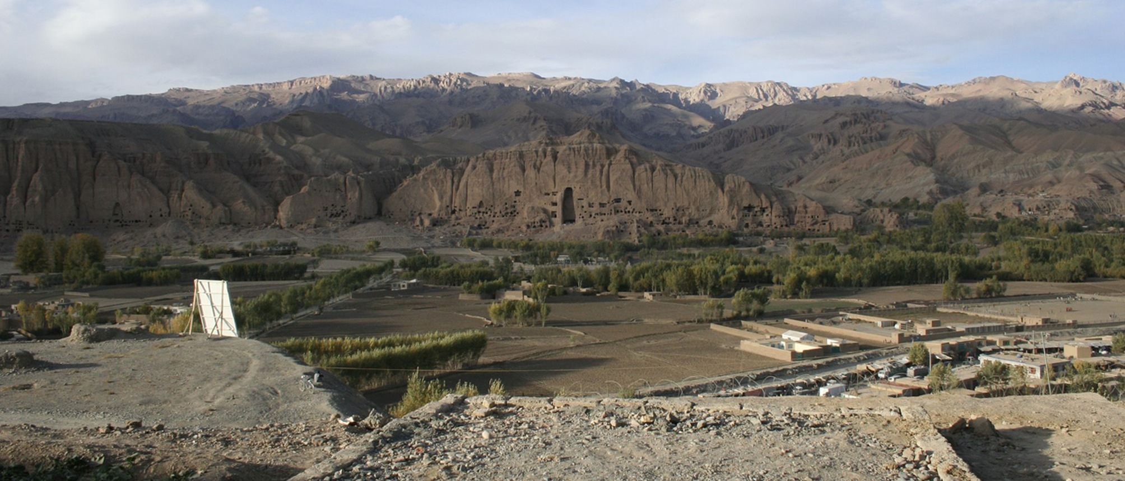
Fig. 1. Bamiyan Valley, Afghanistan (© Irmengard Mayer). .<style CHNT_Figure_Captions>

Figures <style CHNT_Heading 2>
Please use the style <CHNT_Figure> for inserted images. Figures are supposed to fill the entire page breadth, like Fig. 1 or to be centred in the page, like Fig. 2. As an alternative, a figure can be made of different subfigures. In that case, please indicate with a letter each subfigure, and refer to it in the caption, as for example in Fig. 3 using style CHNT_SubfigureLetter. Figures should be ordered and numbered according to the order in which they first appear. Please ensure you refer to each figure in your text. Figures are prefered to be placed in the text. If you absolutely want to add the pictures after the text, please place it after the author statements and before the References.
Please don’t use tables to arrange compound figures. Use tabstops like in Fig. 3. or create a drawing canvas (Insert -> Shapes -> New drawing canvas) to arrange more complex compound figures.
Authors must obtain permission to publish illustrations taken from a copyrighted source. The figure caption must include the appropriate credit information.
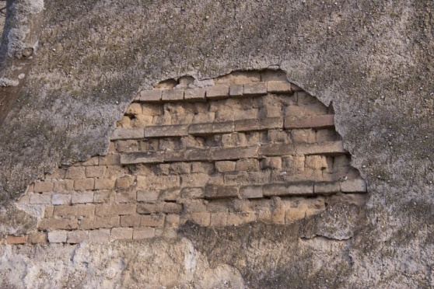
Fig. 2. Mixed masonry of mud bricks and fired bricks, Burgenland (© Irmengard Mayer). .<style CHNT_Figure_Captions>
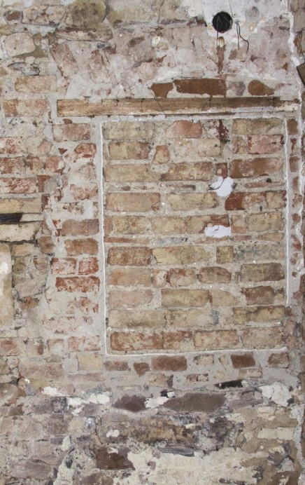
a b c
Fig. 3. Building phases of a window, Weidling, Lower Austria a) phase 1; b) phase 2; c) phase 3 (© Irmengard Mayer).<style CHNT_Figure_Captions>

References in the text
Please use the Harvard Manchester style as a referencing system: http://subjects.library.manchester.ac.uk/referencing/referencing-harvard. Please make sure, URLs and URIs are provided as interactive hyperlink as seen in the examples in the References section below. In the case of references which refer to a range of pages please ensure to use the N–dash instead of “-“ minus to separate the pages. The N-dash is inserted with [Ctrl]+[Numpad “-“]. Eg. (Boasson and Visser, 2017, pp. 210–214).
Author names can also be included in the text, with the year of the publication set in brackets: The citation of the paper by Boasson and Visser (2017) provides a template for citing a Studies in Digital Heritage publication. Polig (2016) published in a CHNT proceedings.

Funding
Please provide information if and by which institutions the research was funded. If applicable, provide the grant number of the funding agency.

Conflict of Interests Disclosure
Please disclose any financial or personal relationships with other individuals or organisations, such as sponsors, that could make your work appear biased or influenced.

Author Contributions
Please list the contributions of the project participants here, according to the CRediT system. See specific descriptions of the role here: (http://credit.niso.org/). Please omit non-applicable roles.
Conceptualization: <contributor names>
Data curation: <contributor names>
Formal Analysis: <contributor names>
Funding acquisition: <contributor names>
Investigation: <contributor names>
Methodology: <contributor names>
Project Administration: <contributor names>
Resources: <contributor names>
Software: <contributor names>
Supervision: <contributor names>
Validation: <contributor names>
Visualization: <contributor names>
Writing – original draft: <contributor names>
Writing – review & editing: <contributor names>

References (3 - max. 5) <style CHNT_Heading 1>
Use the <style CHNT_Reference> for the references. Please make sure, that URLs and URIs are actually working links.
Boasson, W. and Visser, R. M. (2017). ‘SIKB0102: Synchronising Excavation Data for Preservation and Reuse’, Studies in Digital Heritage, 1(2), pp. 206–224. DOI: 10.14434/sdh.v1i2.23262
Polig, M. (2016). The original Holy Cross Church in Dalby. New interpretations through digital archaeology, Proceedings of the 20th International Conference on Cultural Heritage and New Technologies 2015, Vienna, 17 pages. Available at https://www.chnt.at/wp-content/uploads/eBook_CHNT20_Polig_2015.pdf (Accessed: 13 January 2019).

Footnotes concerning a single word should be positioned immediately after the word.
Footnotes concerning a whole sentence should be positioned after the full stop. In-text references must not be written in footnotes. <style CHNT_Footnote>

